SLIP NUMBER 1

QUERY QUESTON NUMBER 3.1

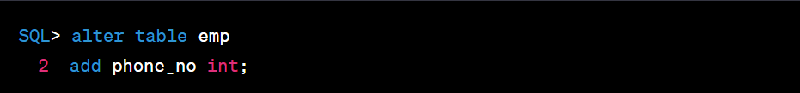

QUERY QUESTON NUMBER 3.2

QUERY QUESTION NUMBER 4.1

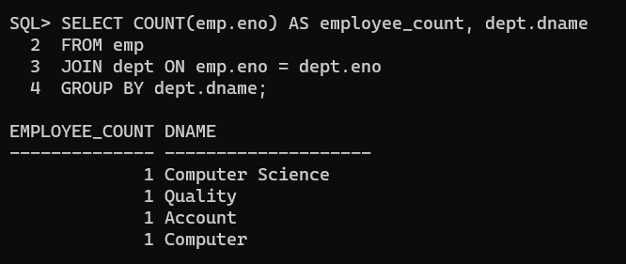

QUERY QUESTION NUMBER 4.2

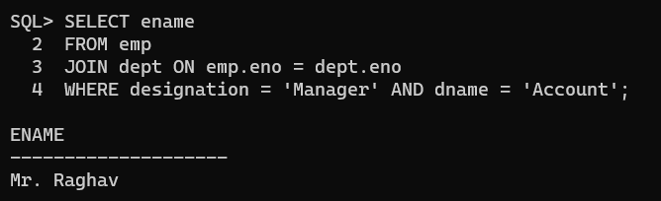

QUERY QUESTION NUMBER 4.3

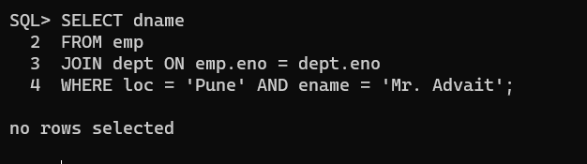

QUERY QUESTION NUMBER 4.4

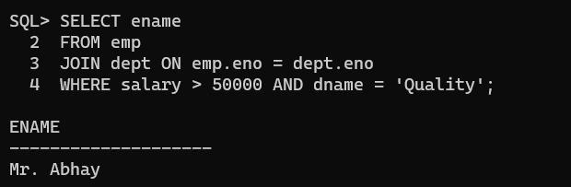

QUERY QUESTION NUMBER 4.5

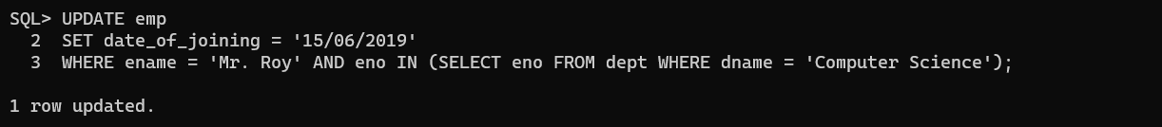

SLIP NUMBER 2

QUERY QUESTION NUMBER 3.1

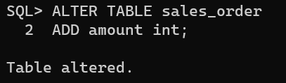

QUERY QUESTION NUMBER 3.2

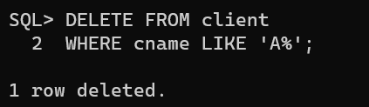

QUERY QUESTION NUMBER 4.1

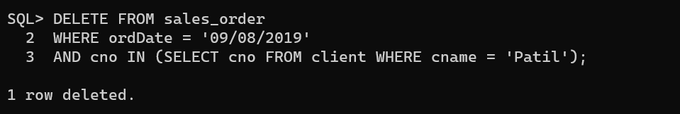

QUERY QUESTION NUMBER 4.2

QUERY QUESTION 4.3

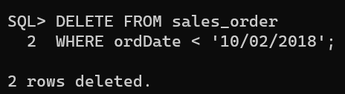

QUERY QUESTION 4.4

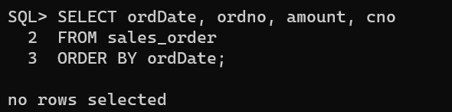

QUERY QUESTION 4.5

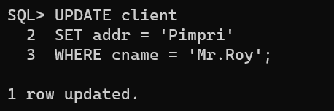

SLIP NUMBER 3:

QUERY QUESTION NUMBER 3.1:

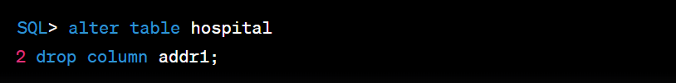

QUERY QUESTION NUMBER 3.1

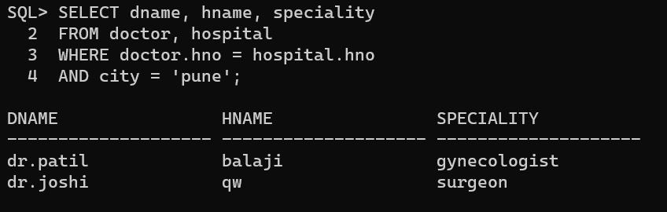

QUERY: QUESTION NUMBER 4.1

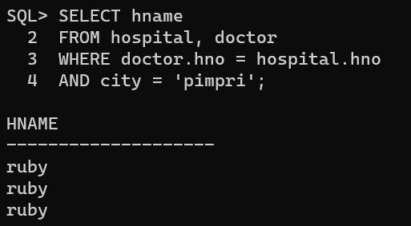

QUERY : QUESTION NUMBER 4.2

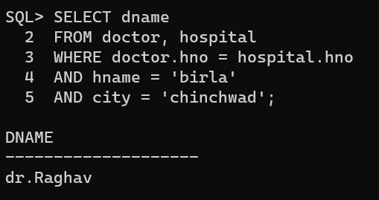

QUERY : QUESTION NUMBER 4.3

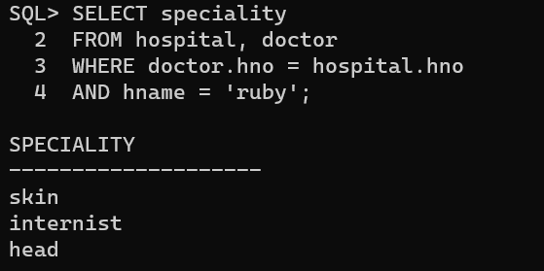

QUERY : QUESTION NUMBER 4.4

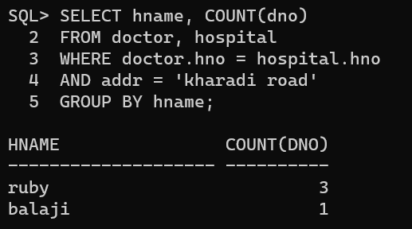

QUERY : QUESTION NUMBER 4.5

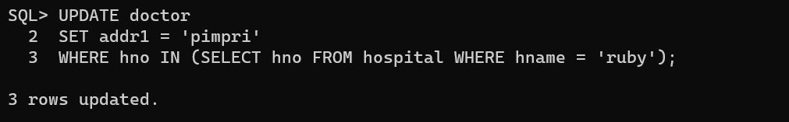

SLIP NO : 4

QUERY : QUESTION NUMBER 3.1

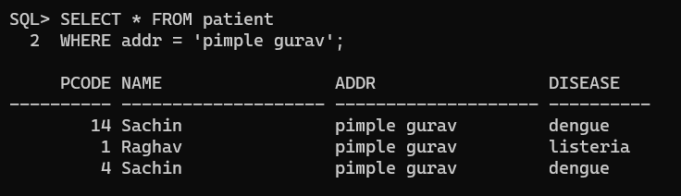

QUERY : QUESTION NUMBER 3.2

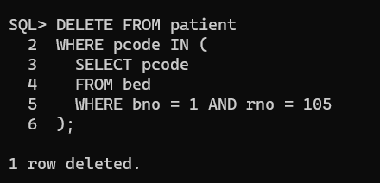

QUERY : QUESTION 4.1

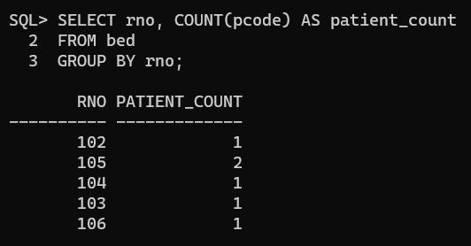

QUERY : QUESTION NUMBER 4.2

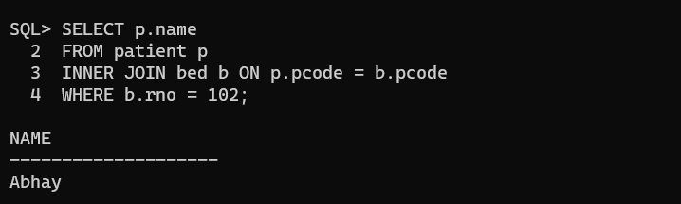

QUERY :QUESTION NUMBER 4.3

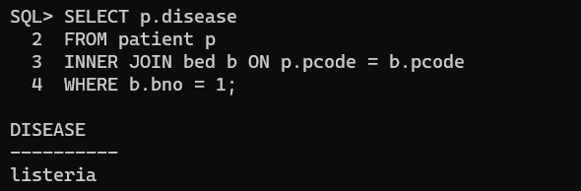

QUERY : QUESTION NUMBER 4.4

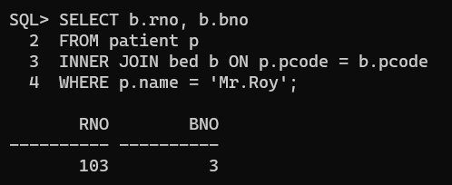

QUERY : QUESTION NUMBER 4.5

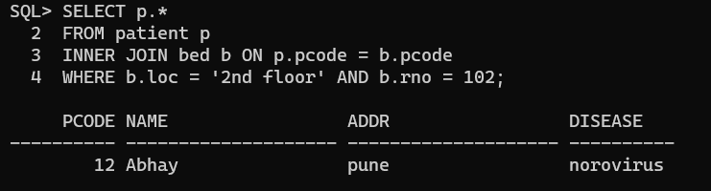

SLIP 5:

QUERY :QUESTION NUMBER 3.1

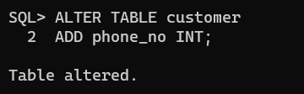

QUERY : QUESTION NUMBER 4.3

